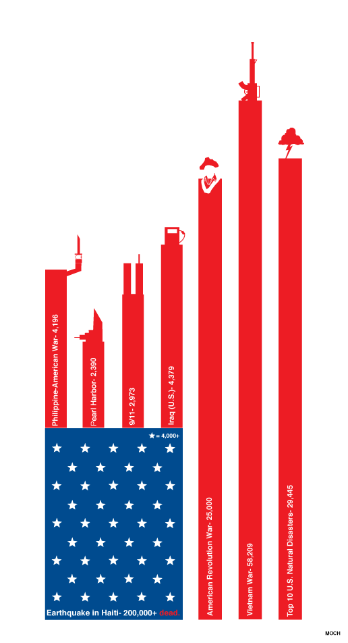

This graph is an atrocity by normal viewing standards, let alone Tufte’s standards. To test, I asked two of my friends not enrolled in this class what they thought this graph was about. They gathered it was about casualties from different world events. I then asked them to, without reading the text, determine which part of the graph represented the largest value. They both answered “the one with the gun on top.” This makes sense, as the bar with the gun on top is the tallest object in the graph. However, that is not at all the point this graph is trying to make. It is trying to show that the Earthquake in Haiti killed way more people than all of these known US historical events. It does, for some godforsaken reason, by imitating an American Flag, denoting the starry part as the Haitian casualties.

As an aside, I am told by my Eagle Scout friend that this graph may be violating modern United States Flag Code.

This graph is misleading. Not only does it obfuscate its own data and cause its viewers to draw incorrect conclusions, it also has a terrible ratio of data-ink, and is generally unappealing as a method of communicating data. A simple bar graph would suffice, as I have recreated below.

As you can see, a simple linear bar graph does a much better job communicating the given data; showing that events such as 9/11 or the Philippine-American War had relatively few casualties, especially when compared to this Haitian Earthquake. The level of data-ink is also more acceptable, and the data is now simply displayed for the viewer to come to their own conclusions.

As a bonus, here is a link that reached the frontpage of Reddit. I’m sure you’ve already seen it but I’d like to highlight it as a fantastic example of an interactive data visualization; http://duelingdata.blogspot.co.nz/2016/01/trump-angry.html